Final Report

Project Title: Personalized News Summarization and Voice Delivery Service Using AI
Team Members:
Name | Student ID | Role
강현욱 (Hyunuk Kang) | C235013 | Team Leader / Backend Development
권민지 (Minji Kwon) | C117009 | Frontend Development
박경빈 (Gyeongbeen Park) | C119170 | Frontend Development
이용호 (Yongho Lee) | C119176 | Backend Development

Table of Contents
- Frontend Architecture and Technology Stack
- User Interface (UI) Design and User Experience (UX)
- Backend Architecture Summary
- Package Structure and Responsibilities
- Core Backend Functionality Implementation
- API Implementation and Testing
- Database Design and Entity Mapping
- Environment and Deployment Configuration
- Reflection and Next Steps
1. Frontend Architecture and Technology Stack
The frontend system of this project has been designed and implemented using React to provide users with a personalized news summarization and voice delivery service. To establish a fast and efficient development environment, it is built upon React + Vite, with pnpm utilized for package management.
Key Technologies:
- React: A declarative and efficient JavaScript library for building user interfaces. Its component-based architecture enhances development productivity by dividing the UI into independent and reusable pieces.
- Vite: A fast and lightweight frontend build tool that significantly improves the development experience by revolutionizing development server startup and Hot Module Replacement (HMR) speeds.
- pnpm: A package management tool that efficiently uses disk space and improves installation speed. It supports efficient dependency management even in monorepo environments, contributing to the project's scalability.
- React Router: The standard library for implementing client-side routing in Single Page Applications (SPAs). It enables smooth transitions between pages and URL-based navigation without compromising the user experience.
- Redux (or Context API): A library for managing application-wide state. It clarifies the data flow between components and enhances maintainability by managing complex data predictably and centrally. (Depending on the project's scale and complexity, either Redux Toolkit or React Context API can be chosen appropriately.)
- Axios: A Promise-based HTTP client available in both browser and Node.js environments. It handles communication with the backend RESTful API easily and efficiently, providing features like request and response interceptors and error handling.
Component-Based Structure and Planning:
The frontend application is composed of clearly separated and reusable components based on their functionality. This approach enhances code modularity and maintainability, and facilitates independent development and testing. The main component plan is as follows:
- Header Component: Located at the top of the application, it includes global elements such as the logo, navigation links, and user login/profile information.
- Footer Component: Located at the bottom of the application, it includes copyright information, company details, and social media links.
- NewsCard Component: A unit component for displaying individual news articles. It includes the news title, summary, like/bookmark buttons, and an audio playback button, allowing users to interact with each article in the news list.
- UserProfile Component: Displays user profile information (e.g., nickname, email) and provides functionality for users to manage their interests and activity history.
- AuthForm Component: A form component used for login and registration. It includes user input validation and logic for calling backend authentication APIs.
- InterestSelector Component: A component that allows users to select and manage their interests.
- NewsDetail Component: A component that displays the detailed content of a specific news article. It includes the full article content, summary, and a TTS audio player.
Styling:
In the initial styling phase, we considered using Emotion, a CSS-in-JS library. However, due to compatibility issues with the latest version, we attempted to switch to Styled Components. The use of Styled Components, however, led to a proliferation of style files per component, resulting in a complex file structure. These early trials highlighted the challenges of maintaining a consistent and scalable styling approach while ensuring development efficiency.
After these trials and errors, we ultimately decided to adopt Tailwind CSS, a Utility-First CSS framework. Our decision was based on the judgment that Tailwind CSS allows for direct style application within HTML markup, which accelerates development, optimizes bundle size, and facilitates the creation of a consistent design system.
The implementation of Tailwind CSS involved the following key steps:
- Installation: We installed Tailwind CSS and its peer dependencies (PostCSS, Autoprefixer) using pnpm: [ pnpm add -D tailwindcss postcss autoprefixer ]
- Initialization: We initialized Tailwind CSS to generate tailwind.config.js and postcss.config.js files, which are essential for configuration: [ pnpm dlx tailwindcss init -p ]
- VS Code Extension: To enhance the development experience, we installed the Tailwind CSS IntelliSense extension in Visual Studio Code. This extension provides features such as autocomplete, syntax highlighting, and linting, significantly improving our productivity when writing Tailwind CSS classes.
Throughout the styling method selection process, we evaluated and compared various alternatives, prioritizing project efficiency and maintainability. Tailwind CSS proved to be the most suitable choice, allowing us to rapidly build a clean and responsive UI.

2. User Interface (UI) Design and User Experience (UX)
Design Principles:
As a personalized news summarization and voice delivery service, this project prioritizes user-centric design principles to ensure users can access news easily and intuitively. In particular, given that it's a web application, we focused on simplicity to optimize usability on relatively smaller screens of mobile and tablet devices compared to PCs.
We minimized features to concentrate on the core value of 'personalized news summarization and voice delivery,' removing unnecessary elements. This approach guides users to consume news content directly without complex configurations or navigation, and to experience a new way of listening to news. Furthermore, we aimed for an accessible design to ensure all users can conveniently utilize the service, and implemented a responsive design to provide a consistent user experience across various devices and screen sizes, ensuring optimal layouts in any environment.
Wireframes and Prototype Implementation Status:
To visualize the initial user flow and key functionalities, Figma was utilized to create wireframes focusing on the essential user authentication process, specifically the login and registration pages. These wireframes served as the foundational blueprint for developing the core user entry points of the application.
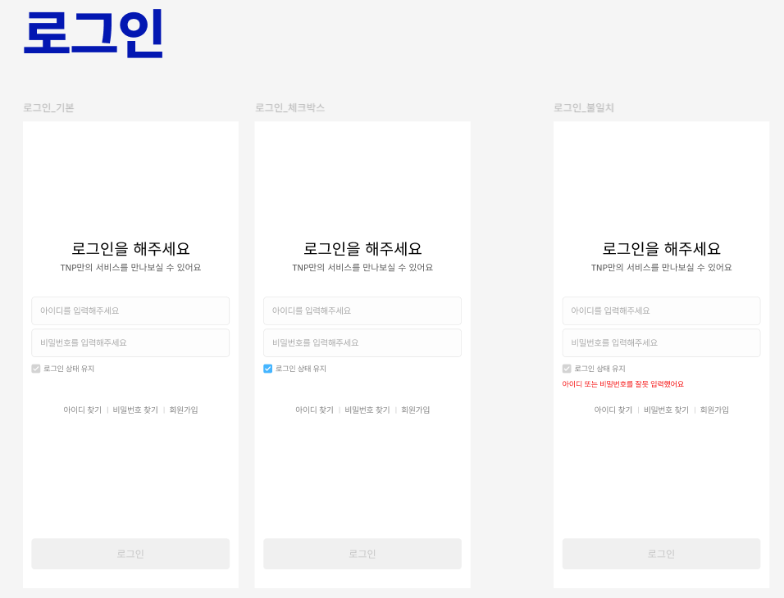
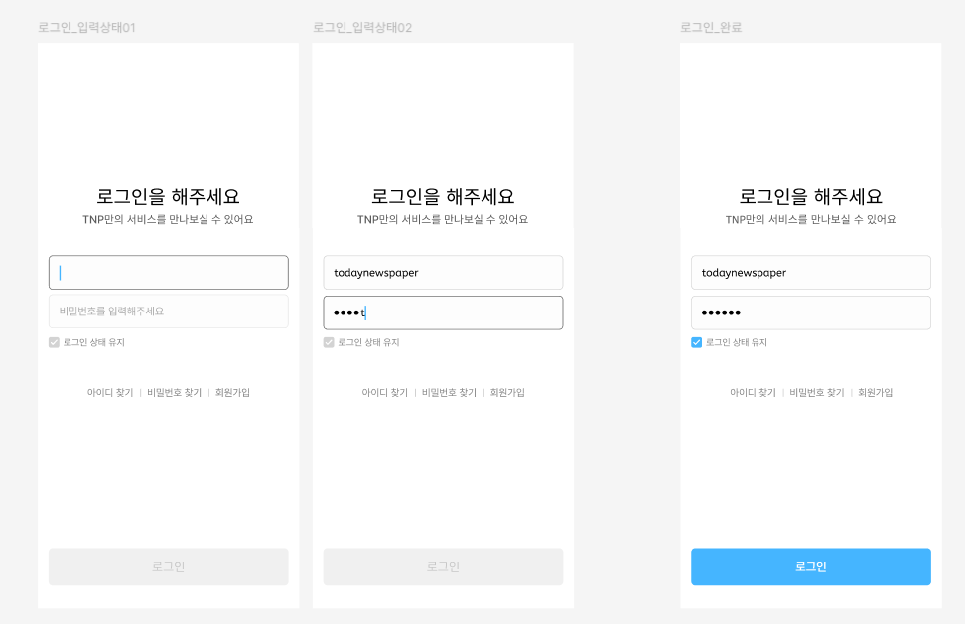
[Image 1: Login Page Wireframe] - Initial design for user login interface.
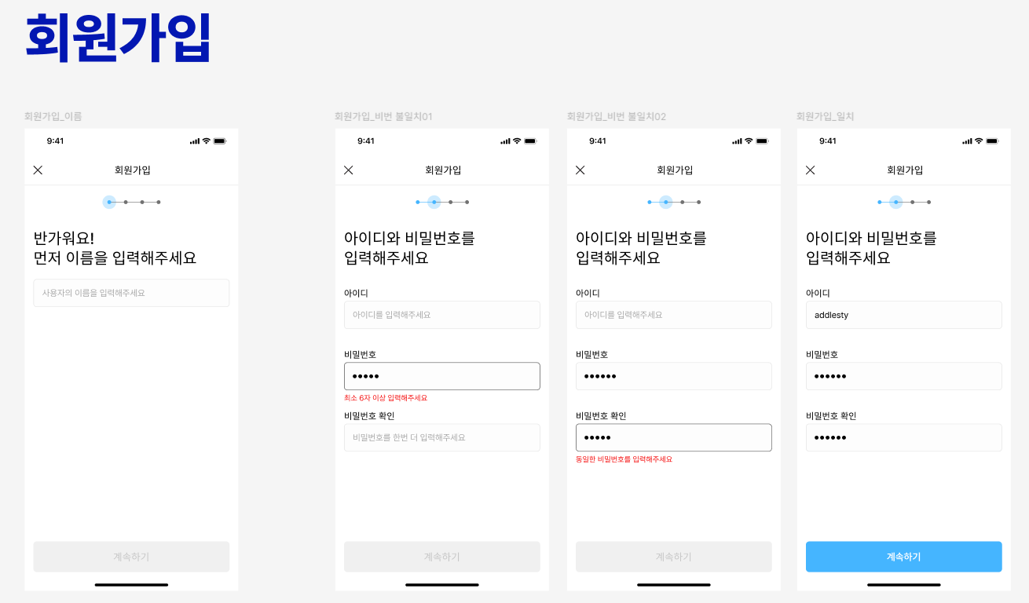
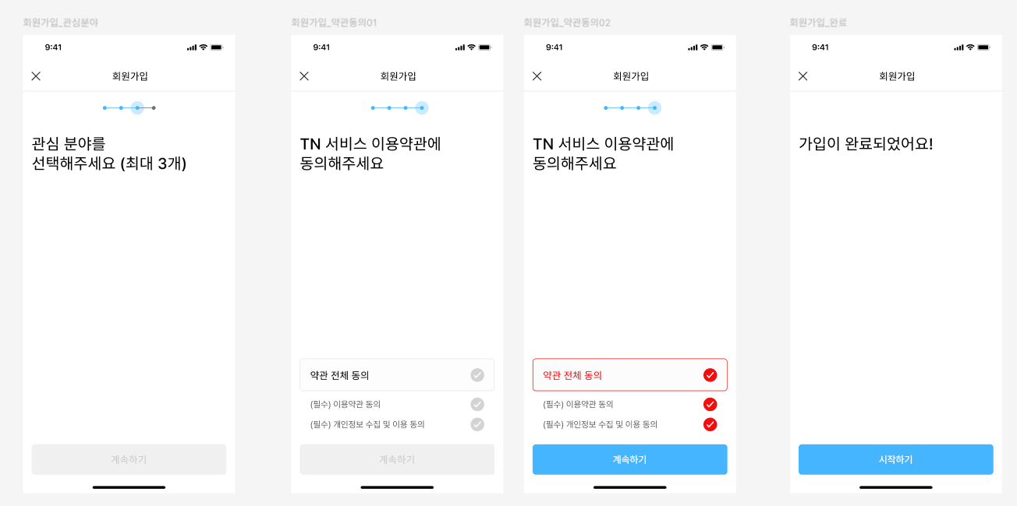
[Image 2: Registration Page Wireframe] - Initial design for user registration interface, including interest category selection.
As of the current prototype stage, the frontend implementation has primarily focused on bringing the login functionality to life. This includes setting up the necessary UI components for user input and integrating with the backend authentication API. The successful implementation of the login feature serves as a crucial first step, validating the chosen frontend architecture and integration strategy. Moving forward, the development will expand to implement the remaining screens and functionalities outlined in the Main Screens/Pages section, leveraging the established component structure and styling approach.
Login Functionality Core Code Snippet: The code below illustrates key parts of the LoginForm and LoginPage components, explaining how user login information is collected and eventually prepared for submission to the backend.
// src/components/LoginForm.jsx (Core logic)
import { useState } from "react";

export default function LoginForm({ onSubmit }) {
const [email, setEmail] = useState('');
const [password, setPassword] = useState('');
const [remember, setRemember] = useState(false);

const isFormValid = email.trim() !== "" && password.trim() !== "";

const handleSubmit = (e) => {
e.preventDefault();
if (!isFormValid) return;
onSubmit({ email, password, remember }); // Pass credentials to parent
};

return (
<form onSubmit={handleSubmit}>
{/* Input fields for email and password */}
<input type="text" value={email} onChange={(e) => setEmail(e.target.value)} placeholder="Email" />
<input type="password" value={password} onChange={(e) => setPassword(e.target.value)} placeholder="Password" />

{/* Checkbox for "Remember me" */}
<label>
<input type="checkbox" checked={remember} onChange={(e) => setRemember(e.target.checked)} />
<span>로그인 상태 유지</span>
</label>

{/* Login button, disabled if form is invalid */}
<button type="submit" disabled={!isFormValid}>
로그인
</button>
{/* Other links like Find ID/PW, Sign Up */}
</form>
);
}

// src/pages/LoginPage.jsx (Core logic)
import React from "react";
import LoginForm from "../components/LoginForm";

export default function LoginPage() {
const handleLogin = (credentials) => {
console.log("Login request data:", credentials);
// TODO: Insert actual API call logic here (e.g., using Axios to call backend login API)
// On success, store JWT token (e.g., in localStorage) and navigate to news feed.
};

return (
<div>
{/* Main container for the login page */}
<LoginForm onSubmit={handleLogin} /> {/* Render the LoginForm component */}
</div>
);
}
This code demonstrates how the LoginForm component handles user input and UI interactions, while the LoginPage component utilizes this input to define the handleLogin function, which will initiate communication with the backend. The TODO comment within handleLogin indicates that Axios-based HTTP requests and response handling will be implemented in the future.
Moving forward, the development will expand to implement the remaining screens and functionalities outlined in the Main Screens/Pages section, leveraging the established component structure and styling approach.
Main Screens/Pages (Planned):
While the current implementation focuses on user authentication, the full vision for the frontend encompasses the following key screens, which will be developed in subsequent phases:
- Registration/Login Page (/signup, /login): This is the first gateway for users to access the service, providing intuitive form input fields and clear guidance messages. During registration, users are prompted to enter their email, password, nickname, and select up to 3 interest categories. These interests play a crucial role in personalizing the user's news feed. Upon successful login, a JWT token is issued to maintain user authentication without sessions.
- Interest Selection Page (/interests): After registration or login, this screen allows users to select or change their interest news categories (e.g., politics, technology, sports). It visually presents various interests using checkboxes or tags, along with a clear notice for the limit of up to 3 selections. This ensures users can easily select and modify their preferences. Selected interests are stored in the backend and used for personalized news recommendations.
- Personalized News Feed (/news): This is the main screen displaying a list of news articles recommended based on the user's selected interests. Since this service provides 'Today's News,' separate publication dates or source information are not displayed on news cards. Instead, the focus is on providing users with fresh news updated daily. Each news article is displayed as a NewsCard component, including the title and a brief summary. The news card intuitively includes 'Like' and 'Bookmark' buttons for the article, as well as a 'Play' button to listen to the summarized content via audio. An infinite scroll feature allows loading additional news as the user scrolls, providing a seamless news consumption experience.
- Individual News Article Detail Page (/news/{id}): This screen displays the detailed content of a specific news article when a user clicks on a news card in the feed. It provides the full original article content (scraped body), an AI-generated summary using OpenAI's GPT API, and a player for the summarized audio file converted via Amazon Polly. 'Like' and 'Bookmark' functionalities are also available on this page to encourage user interaction.
- My Page/Activity Dashboard (/profile): This page allows users to view and modify their account information (e.g., nickname, email). It will be structured to allow users to easily view their activity history, including liked news, bookmarked news, and listened news. Through this, users can understand their news consumption patterns and easily revisit desired articles.
Interactive Elements:
The frontend includes various interactive elements to maximize user interaction and provide an intuitive user experience.
- News Card Interactions:
- 'Play' Button: Clicking the 'Play' button located within a news card initiates the TTS audio playback of that news summary. This functionality is provided through backend integration with Amazon Polly.
- 'Like' and 'Bookmark' Buttons: Each news card includes 'Like' and 'Bookmark' function buttons, allowing users to easily save articles of interest or express their preference. These interactions are stored in the backend database to track user activity.
- News Card Click: Clicking on a news card navigates the user to the article's detail page, where they can view the full content, AI summary, and TTS audio playback in more detail.
- Form Elements: All forms requiring user input, such as registration, login, and interest selection, provide clear labels, placeholders, and input validation feedback to help users enter information without errors.
- Navigation: Intuitive top header navigation (e.g., Home, My Page) and bottom footer links are designed to allow users to easily move between different sections within the application.
- Loading and Feedback: During data loading, spinners or placeholder UI are displayed to inform the user that the service is functioning correctly. Clear feedback, such as toast messages or notifications, is also provided upon API call success or failure, ensuring a smooth user experience.

3. Backend Overview and Architecture Summary
This project is a personalized news summarization and voice delivery service that recommends news articles based on user interests, summarizes them using AI, and converts the summaries into speech. After signing up and selecting preferred categories, the user receives news updates automatically collected three times a day. Each article is summarized using OpenAI's GPT API, and the resulting summary is converted into speech via Amazon Polly. Users can consume the news in either text or audio format.
The backend system was implemented as a Spring Boot-based REST API server, following the architecture outlined in the midterm report. The system is organized into multiple layers:
- the Controller layer for handling client requests,
- the Service layer for core business logic,
- the Util and Agent layer for interacting with external APIs and utilities,
- and the Repository layer using JPA for data persistence.
The backend integrates the following technologies:
- Spring Boot + JPA for API development and database interaction
- MySQL as the primary relational database
- Amazon Polly + AWS S3 for voice synthesis and storage
- OpenAI GPT API for automated article summarization
- Spring Security with JWT for user authentication
- Spring Scheduler to automatically crawl news articles three times per day
Compared to the original midterm design, several practical implementations were adapted during development:
- Preparation for MCP integration: Although the current system directly interacts with external APIs, the architecture includes abstraction layers (AgentRunner, SummaryContext, and TtsContext) to support future integration of Model Context Protocol (MCP), allowing easy substitution of AI agents.
- S3 and Polly utility structuring: A dedicated utility class (S3Uploader) was implemented to modularize and simplify the process of uploading mp3 audio files to Amazon S3, improving maintainability and reusability.
- Automated crawling via Scheduler: The system uses Spring Scheduler to perform automated news crawling at 9 AM, 1 PM, and 7 PM daily. Duplicate checks were also implemented to prevent redundant entries based on article URLs.
Overall, the architecture follows the original design plan from the midterm report and was successfully implemented as a high-quality backend prototype suitable for integration with the frontend or further expansion.

4. Package Structure and Responsibilities
The backend system was organized following a clear multi-layered architecture to ensure separation of concerns, modularity, and scalability. Each package was structured to isolate responsibilities such as request handling, business logic, data persistence, utility support, scheduling, and AI model integration.
The overall package structure is as follows:
├── controller/
├── service/
├── repository/
├── domain/
├── dto/
├── scheduler/
├── agent/
├── util/
├── config/
└── exception/
Descriptions of each package:
- controller/:
Contains REST controllers that handle incoming HTTP requests and route them to the appropriate services. For example, NewsController manages requests for retrieving personalized news, and AuthController handles user registration and authentication.
- service/:
Implements the core business logic of the application. Each service is focused on a single responsibility, such as SummaryService for interacting with the GPT summarization API, or TtsService for processing voice generation and file uploads to AWS S3.
- repository/:
Includes JPA repository interfaces for interacting with the MySQL database. These extend JpaRepository and provide access to entities like User, News, Summary, and Tts.
- domain/:
Contains entity classes annotated with JPA (@Entity) that represent database tables. Relationships such as @ManyToOne, @OneToOne, and @ManyToMany are properly modeled to reflect the ERD designed during the planning phase.
- dto/:
Defines Data Transfer Objects (DTOs) used for handling request and response bodies. This helps decouple internal domain models from external API representations, improving flexibility and security.
- scheduler/:
Contains scheduled tasks, particularly the NewsCrawlingScheduler class which performs automatic crawling of news articles three times daily using Spring's @Scheduled annotation.
- agent/:
Introduced to support future integration with MCP (Model Context Protocol). It includes abstractions like AgentRunner, SummaryContext, and TtsContext that decouple service logic from specific AI model implementations.
- util/:
Includes utility classes such as S3Uploader for uploading audio files to Amazon S3 and JwtUtil for handling JWT token generation and validation.
- config/:
Holds security and environment-related configuration classes, including SecurityConfig for Spring Security setup and CORS configuration, and DockerProfileConfig for containerized deployment.
- exception/:
Contains custom exception classes and a GlobalExceptionHandler annotated with @ControllerAdvice to provide centralized error handling across the application.
This structure was intentionally designed to allow for independent development, easier testing, and future scalability. In particular, the inclusion of the agent package from the beginning ensured that the system could later integrate more advanced AI execution mechanisms (e.g., MCP) without significant refactoring.

5. Implementation of Core Backend Features
This section describes the implementation of the system’s core backend functionalities, including news crawling, AI-based summarization, TTS conversion, and user authentication.
5.1 News Crawling via Scheduler
To automate content collection, the system implements a scheduled news crawling feature using Spring's @Scheduled annotation. The NewsCrawlingScheduler class is configured to run three times a day- at 9 AM, 1 PM, and 7 PM -to populate the news database with updated articles.
For testing and prototyping purposes, the current implementation uses a temporary external API called news-api to retrieve sample article data in JSON format. The system extracts article metadata such as title, description, publication date, and URL from this source. The fetched URLs are then used with Jsoup to scrape the full article content directly from the article’s source webpage.
To avoid redundant data, the system checks whether the article’s URL already exists in the database. If not, the content is saved into the News table and queued for later summarization and TTS conversion.
While this approach works effectively for prototype validation, it is designed with future scalability in mind. The current architecture allows easy replacement of the data source. In the next stage of development, the system will be extended to integrate with Naver News Open API, which will enable dynamic keyword-based article collection aligned with each user’s selected interests.
5.2 Article Summarization (Prototype Stage)
To support future integration of automated summarization, the system includes a module called SummaryService, which is responsible for handling news summarization logic. While the actual connection to the OpenAI GPT API has not yet been implemented, the system architecture is designed to support it easily.
Specifically, the logic is abstracted through the AgentRunner interface and SummaryContext class, allowing the summarization feature to be implemented later via an external agent or model using the MCP (Model Context Protocol) approach. This design enables minimal code changes when the GPT API or another AI service is integrated.
Currently, the system either skips summarization or uses placeholder values to simulate the workflow. Before full deployment, this module will be expanded to send actual article content to the GPT API and store the returned summary in the Summary table.
5.3 Text-to-Speech and S3 Upload (Prototype Stage)
To provide voice accessibility for summarized news, the system includes a Text-to-Speech (TTS) module based on Amazon Polly. Although the actual API integration with AWS Polly and S3 has not yet been completed, the architecture is fully prepared to support it.
The core logic is implemented in the TtsService class, which is designed to convert a given summary into speech using Polly's SDK. The system simulates the process by assuming that once a user clicks the "play" button on the frontend, the summary is converted to an mp3 file and played back.
To support future AWS integration, a utility class named S3Uploader was implemented. It is responsible for uploading generated audio files to Amazon S3, handling file naming conventions and access URLs. These URLs are intended to be stored in the Tts table and linked to each summarized article.
Although the current version does not execute real API calls, the service flow is designed to be easily extended. Through the AgentRunner interface and TtsContext abstraction, the TTS module can later be connected to either AWS Polly or other third-party AI voice services.
5.4 JWT Authentication
To support user-level customization and secure access to API endpoints, the backend system implements token-based authentication using JWT (JSON Web Token). This functionality was developed using Spring Security and is responsible for managing user login, signup, and authorization.
When a user signs up through the /api/signup endpoint, their account information is stored in the database with an encrypted password. During login (/api/login), the system verifies the user's credentials and generates a JWT token upon successful authentication. This token includes the user’s unique ID and is signed using a secret key.
The token must be included in the Authorization header (as a Bearer token) in subsequent API requests. A custom JwtAuthenticationFilter class intercepts these requests and validates the token. If valid, the user's identity is extracted and granted access to protected resources.
This JWT-based approach eliminates the need for server-side session storage and allows stateless authentication, which is scalable and well-suited for RESTful API services.

6. API Implementation and Testing
The backend system provides a RESTful API interface that supports user registration, login, interest selection, personalized news retrieval, summary playback, and bookmarking. Each endpoint follows REST design principles and is protected with JWT-based authentication where appropriate.
Endpoint | Method | Description | Auth Required
/api/signup | POST | Register a new user | No
/api/login | POST | Log in and receive JWT | No
/api/interests | GET / POST | Retrieve all available interests / Submit user's selected interests | Yes
/api/news | GET | Retrieve personalized news list | Yes
/api/news/{id} | GET | Retrieve a single news article with summary | Yes
/api/news/{id}/audio | GET | Retrieve TTS audio URL of the summary | Yes
/api/news/{id}/like | POST / DELETE | Like or unlike an article | Yes
/api/news/{id}/bookmark | POST / DELETE | Bookmark or unbookmark an article | Yes
To access any authenticated endpoint, the JWT token must be included in the Authorization header in the format: Authorization: Bearer <JWT_TOKEN>
So far, the functionality of the user signup, login, interest registration, and personalized news list retrieval APIs has been verified using Postman.
Interactive features such as retrieving individual news articles, playing audio summaries, and performing like or bookmark actions are planned to be tested in the next phase.
All tested endpoints returned correct HTTP status codes and expected JSON structures, confirming that the overall authentication flow and user request handling logic are working as intended.

7. Database Design and Entity Mapping
The database schema of this project was designed to support user-personalized news summarization and voice delivery. The core entities include User, News, Summary, Tts, Interest, Bookmark, and their associated relationships.
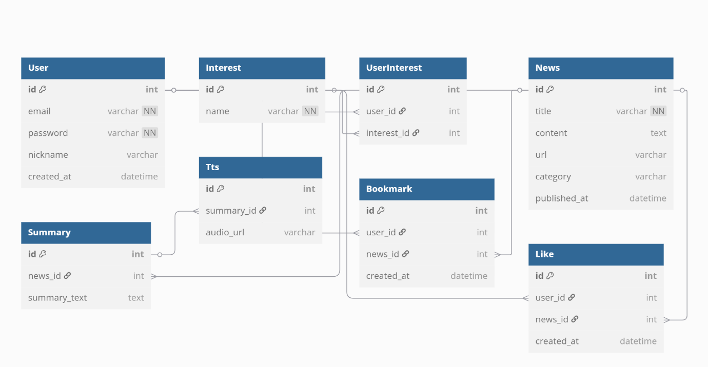Entity Structure Overview
- User: Stores user credentials and profile information.
- Interest: A predefined list of categories (e.g., politics, technology) that users can select.
- UserInterest: A join table (many-to-many) linking users to their selected interests.
- News: Stores articles collected via crawling, including title, content, URL, and category.
- Summary: A one-to-one table containing the summarized version of each article.
- Tts: A one-to-one table that holds the mp3 file URL generated from the summary.
- Bookmark, Like: Join tables tracking user interaction with news articles.
JPA annotations such as @OneToOne, @ManyToOne, and @ManyToMany were used to represent the relationships between these entities. The database is managed using MySQL, and Spring Data JPA is used for data persistence and querying.
Relationship Mapping
- Each User can select multiple Interest values (@ManyToMany)
- Each News article is associated with exactly one Summary (@OneToOne)
- Each Summary may have one corresponding Tts entry (@OneToOne)
- User ↔ News interactions like Bookmark and Like are tracked via separate join tables
The ERD originally designed in the midterm report was mostly preserved, with slight modifications for implementation purposes (e.g., simplified composite key handling by introducing surrogate IDs in join tables).
This design enables scalable personalization and efficient user interaction tracking, while maintaining clear relational structure and extensibility.

8. Environment and Deployment Configuration
The backend system was developed and tested in a local environment using Spring Boot and MySQL, with a structure designed to support containerized deployment using Docker in future stages.
Application Configuration
All environment-specific settings such as database credentials, API keys, and server ports are managed using the application.yml file. The system supports multiple profiles (e.g., local, docker), allowing flexible configuration based on the runtime environment.
The application is designed to apply different configurations depending on the selected Spring profile. For example, profiles such as local or docker can be used to activate specific environment settings, and the active profile can be specified through command-line arguments or environment variables at runtime.
Key settings include:
- Database configuration (host, port, username, password, db name)
- JWT secret key and token expiration time
- Placeholder fields for OpenAI, AWS S3, and Polly integration
- CORS settings and security filter configuration
Deployment Considerations
Although the current system was tested locally using an IDE, the codebase is structured to support Docker-based deployment. A sample Dockerfile is included in the project, and future deployment will utilize docker-compose.yml to integrate backend, database, and potentially frontend and NGINX into a unified development environment.
The architecture also supports future scalability via container orchestration tools such as Kubernetes.

9. Reflection and Next Steps
Throughout the backend development process, the team successfully implemented the core functionality required for a personalized news summarization and voice delivery service. The primary focus was to design and build a robust and maintainable backend infrastructure that could serve as the foundation for scalable, AI-driven content delivery. Each component was developed with clear responsibility boundaries, following a layered architecture and modular design principles. This allowed for independent development of various features such as news crawling, summarization, audio generation, and user authentication.
One of the main technical goals was to ensure that the system remained adaptable to future enhancements, particularly in the areas of AI model switching and external service integration. The team aimed not only to make the system functional in its current state, but also to prepare for long-term maintainability and ease of feature expansion.
During development, key challenges included structuring the data flow across multiple external services such as OpenAI (for summarization) and Amazon Polly (for text-to-speech conversion). Each of these services has different request/response structures, rate limits, and authentication methods, which introduced complexity in maintaining a unified flow. Additionally, it was necessary to ensure that these services could be replaced or extended in the future without tightly coupling them to the core logic.
To address these issues, the team designed a set of abstract interfaces—such as AgentRunner, SummaryContext, and TtsContext—that serve as intermediaries between the core services and the external AI modules. These abstractions not only simplified current development, but also made it feasible to adopt the Model Context Protocol (MCP) in future stages. By following this approach, the backend is now capable of seamlessly integrating with different AI models or orchestration agents without requiring major codebase refactoring.
Future Work
In the next phase of development, the following tasks are planned:
  - Backend
- Recommendation Algorithm Enhancement: To improve the accuracy of personalized recommendations, a category-based scoring algorithm will be developed. The system will analyze user interactions—including likes, bookmarks, and reading frequency—to assign dynamic weights to news categories. This behavior-driven model will allow the news feed to be continuously refined according to each user’s interests and engagement patterns.
- MCP Server Setup: As the backend has already been designed with AgentRunner interfaces and Context objects, it is well-prepared for integration with an MCP (Model Context Protocol) server. In future development, a dedicated MCP server will be built to handle summarization and text-to-speech operations via pluggable AI agents. This architecture improves modularity and allows easy switching between different models or orchestration methods. These enhancements will move the project closer to becoming a fully functional, deployable system capable of delivering intelligent and accessible news experiences.
- User Activity Dashboard & Analytics: A user activity dashboard will be introduced to allow users to track their interaction history, including viewed articles, listening time, and bookmarked content. On the admin side, basic analytics (e.g., most-read categories, engagement by time) could be collected to inform future UX improvements or content strategy.
  - Frontend
Currently, frontend development is in the stage of setting up the React + Vite, pnpm, and Tailwind CSS environment, and designing the core component structure. To build an efficient and robust frontend system, we plan to focus on the following steps:
- Implementation of Core Features and Backend API Integration: Based on the currently designed wireframes, we will primarily focus on fully integrating core UI components with the backend API. This includes functionalities such as user registration/login, interest selection, personalized news feed display, news detail view (including summary and audio), and like/bookmark features. The goal is to ensure smooth data flow according to user interaction and for the service to operate functionally.
- Enhancement of UI/UX Completeness: Utilizing Tailwind CSS and building upon the Figma wireframes, we will proceed with materializing the visual design of all screens and intuitively improving the user experience. While maintaining the 'simplicity' design principle, we will concentrate on enhancing UI completeness by meticulously adjusting the placement of each element, colors, and typography to enable users to immerse themselves in the service and operate it easily. Special emphasis will be placed on touch responsiveness and readability in mobile environments.
- Stable Operation and Error Handling: We will implement clear feedback and appropriate error handling logic for various error situations that may occur during communication between the frontend and backend (e.g., network issues, server errors, user input errors). This is crucial for providing a stable service without compromising the user experience.
- Initial Phase of Performance Optimization: From the early stages of development, we will strive to ensure the overall responsiveness of the service by writing code with basic performance optimization techniques in mind, such as bundle size management and component rendering optimization.
This frontend development plan aims to synergize with the backend system's completeness, successfully delivering the core value of a 'personalized news summarization and voice delivery service' that users expect.

